URBAN GARDEN MANAGEMENT
@CREATIVITY THINK (9483175986/7019689991)

ABSTRACT:
Urban Garden Management is a web-based platform designed to support community gardens, city gardening groups, and educational institutions in organizing and managing shared garden spaces. The system enables users to register garden plots, access event calendars, place supply orders, participate in member discussions, and track overall garden activity through a dashboard. Administrators can manage plots, schedule events, process supply requests, and view analytical reports for governance. Built using Django and Django Rest Framework on the backend and React with Redux and Recharts on the frontend, the platform provides an efficient, collaborative, and structured approach to community garden administration..

INTRODUCTION OF THE PROJECT:
Community gardening initiatives have increased across cities, schools, and residential groups, but many struggle with managing shared resources, event coordination, plot assignments, and communication. Manual systems often lead to confusion, overlapping reservations, supply shortages, and lack of transparency. Urban Garden Management addresses these challenges by providing a centralized digital platform for structured plot allocation, event scheduling, member communication, and supply management. With strong backend APIs and interactive frontend dashboards, the system streamlines community engagement and strengthens collaborative gardening culture..

PROJECT OBJECTIVES:

• Provide a digital registry for garden plots and member teams
• Enable users to reserve calendar slots and participate in scheduled events
• Allow members to place supply orders for gardening materials
• Support community interaction through discussion boards
• Offer administrators tools to manage plots, events, and supplies
• Deliver analytics dashboards for monitoring activity and usage trends
• Improve transparency, communication, and organizational efficiency
• Enable scalable management for small and large community gardens

PROBLEM OF THE STATEMENT:
Urban garden groups frequently face challenges related to unorganized plot allocation, mismanaged schedules, poor communication, and inefficient supply distribution. Manual methods lack centralization, making it difficult for members to coordinate and for administrators to monitor activities effectively. The Urban Garden Management platform solves these issues by providing a unified digital system where plot assignments, event calendars, supply orders, and community discussions are managed seamlessly, ensuring orderly operations and improved participation..

MOTIVATION OF THE PROJECT:
• To promote structured and organized community gardening
• To eliminate confusion in plot allocation and event scheduling
• To ensure a transparent method for supply ordering and distribution
• To create a collaborative digital community for gardeners
• To help administrators monitor activities with ease
• To provide dashboards and analytics for better decision-making
• To build a scalable system suitable for various garden group sizes

BLOCK DAIGRAM OF PROJECT:

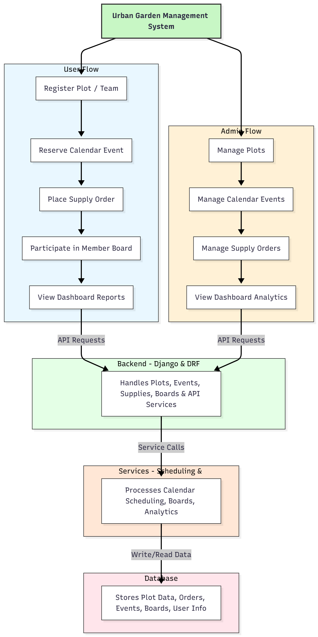

WORKING OF THE PROJECT:
The system begins by allowing users to register their plot or team in the platform. Once registered, users can explore the event calendar and reserve time slots or participate in scheduled gardening activities. Members may place supply orders for seeds, tools, or fertilizers, which administrators manage and approve. The discussion board allows community members to exchange gardening ideas, coordinate tasks, and stay informed. Administrators oversee plot assignments, manage events, and monitor supply orders. All interactions are processed through backend APIs, stored in the database, and displayed in dashboard analytics for transparent and efficient garden management..

SOFTWARE REQUIREMENT:
- Backend:
  - Python 3.x
  - Django
  - Django REST Framework
  - SQLite/PostgreSQL
- Frontend:
  - Node.js and npm
  - React.js
  - Axios
- Development Tools:
  - Visual Studio Code
  - Postman (for testing APIs)
  - Git/GitHub (for version control)
- Server/Deployment (Optional):
  - Gunicorn, Nginx, or Heroku/AWS for hosting

ADVANTAGES OF THE PROJECT:

• Promotes organized and efficient community gardening
• Centralized plot, event, and supply management
• Real-time updates and transparent communication
• Reduces manual errors and scheduling conflicts
• Engages members through discussion boards
• Supports administrators with smart dashboards
• Scalable for various garden types and sizes
• Enhances collaboration and shared productivity

APPLICATIONS OF THE PROJECT:
• Urban community garden groups
• Residential societies with shared garden spaces
• City-based gardening and environmental groups
• Schools and educational gardening clubs
• Public garden management committees

REFERENCES:

- Django REST Framework Documentation — Django Software Foundation. Django Documentation. Available: https://docs.djangoproject.com/
- Django REST Framework. DRF Documentation. Available: https://www.django-rest-framework.org/
- React. React Official Documentation. Available: https://reactjs.org/docs/getting-started.html
- Redux. Redux Documentation. Available: https://redux.js.org/introduction/getting-started
- PostgreSQL Global Development Group. PostgreSQL Documentation. Available: https://www.postgresql.org/docs/
- MySQL. MySQL Reference Manual. Available: https://dev.mysql.com/doc/
- Git. Git Documentation. Available: https://git-scm.com/doc
- Node.js. Node.js Documentation. Available: https://nodejs.org/en/docs/
- Axios. Axios Documentation. Available: https://axios-http.com/docs/intro
- Socket.io Documentation – https://socket.io/docs/

